1. Purpose and Scope
   1. This paper reviews the use of HTML, JavaScript, and ASP.NET code in developing web applications. This paper is part of the CSHP 812 Assignment 01 Deliverable.
2. Hyper Text Markup Language (HTML)

HTML is a markup language used to create web pages. It provides a means to present content within a browser.

The HTML markup is comprised of tags that define the various parts of a document. An example is given below.

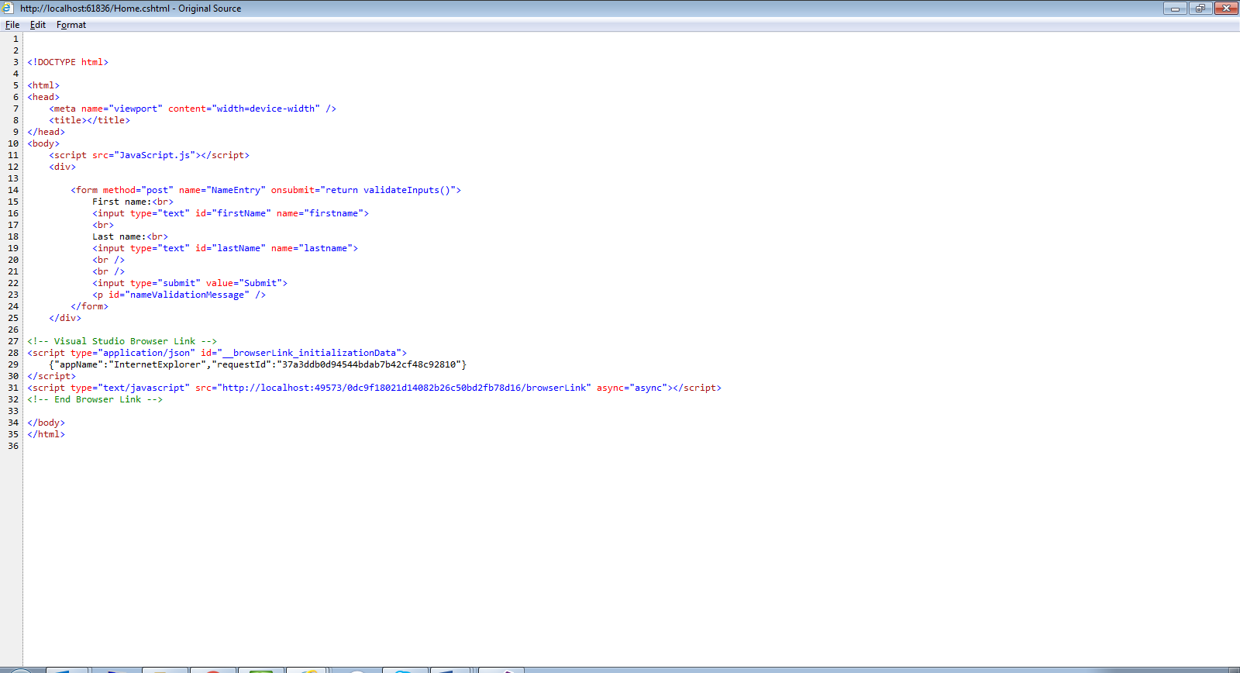

1. JavaScript

JavaScript is a scripting language that is embedded in webpages to provide functionality within a web page. The code executes on the local machine and not on the server. JavaScript methods are useful in improving control responsiveness and reducing traffic to and from the server for operations that can be handled locally.

An example of this would be in validating that the text written to a textbox abides by some rules, such as the textbox is not empty. An example is given below

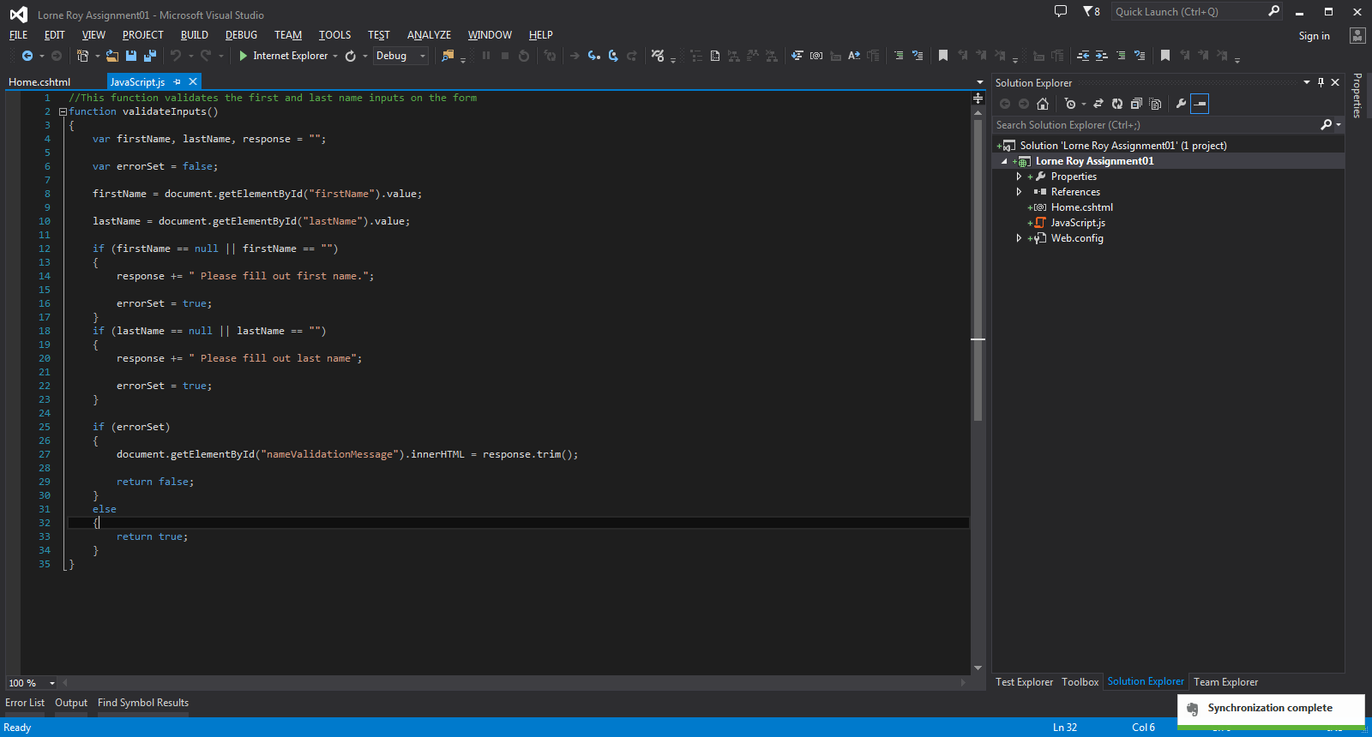

1. ASP.NET

ASP.net is a programming language for use with web pages. Unlike JavaScript, ASP.net methods reside and are executed on the web server.

An example of this would be in performing a query of a database from the input given on a webpage, then returning the results to the client.

1. References
   1. “HTML(5) Tutorial”. w3schools.com. Web. 19MAR2016
   2. “JavaScript Tutorial”. w3schools.com. Web. 19MAR2016
   3. “HTML Introduction”. w3schools.com. Web. 19MAR2016